My Splunk Homelab Documentation
Phase 1: Installing
- Self Explanatory just install then login into port 8000 in your preferred web browser, and sign in using the credentials you made when downloaded splunk enterprise.
Phase 2: Installing the pre-built pile of security logs I can study BOTSV3 (Boss of the SOC v3)
- Look for the BOTSv3 repository on github and install it
- After installing install it as an app on your splunk.

Learnings from Phase 2:
To identify all the sourcetypes we can just use the search bar to look up all the sourcetypes. Using index=”your index” | stats count by sourcetype | sort – count
- This will search our index and count the sourcetypes we have in our index and sort it in descending order. So the sourcetype with most events logged will be on top.
- Some sourcetypes are self explanatory such as linux_secure and WinEventLogs but most names often hint at their source, but in order to further actually see what they are or what they contain inspect their raw event or look them up.
ReverseMapping and ForwardMapping
- ReverseMapping uses the IP to ask DNS for the hostname connected to.
- ForwardMapping using the hostname it got from reverse mapping it then asks DNS what IP the hostname is linked to or what it points to validate if they truly match.
Verdict a failed FRcDNS (Forward Confirmed Reverse DNS) is not often a sign of compromise but it is considered by some as a minor flag.
If you don’t know what field to look for you can use the fieldsidebar on the left side.
The workflow is always discover -> confirm -> query
The host field is usually the victim not the attacker. The constant value e.g contant ip in any event is most likely always the machine that is writing the logged.

Phase 3:
Sysmon
- SysMon is a free Microsoft Sysinternals tools which logs detailed system activities on the windows operating system such as process creation, network connections, and any changes withing files or the registry. which windows does not normally record by default. So basically, we use sysinternals so we can get logs or event information from the client being monitored by splunk, the information logged by Sysmon will be forwarded using the universal forwarder to splunk for monitoring.
Installed SysMon (Microsoft Sysinternals) and “SwiftOnSecurity sysmon-config”
Afterwards, add a new receiving port on your splunk vm, add 9997 as the new receiving port so you can receive forwarded logs on that port.
Install splunk universal forwarder on the machine you want or will be monitoring in splunk, proceed to setup the universal forwarder. After installing go to C:\Program Files\SplunkUniversalForwarder\etc\system\local to create an inputs.conf file with the contents being:
[WinEventLog://Security]
disabled = 0

[WinEventLog://Microsoft-Windows-Sysmon/Operational]
disabled = 0

dunking the inputs.conf file:
[WinEventLog://Security] and [WinEventLog://Microsoft-Windows-Sysmon/Operation]
- These are called stanza headers and these define an input. Inputs are where we get our data from, it’s a source of data to collect hence why its input. WinEventLog:// is the input type its what tells the splunk forwarder what to read so for this instance it tells the forwarder to read the WinEventLog:// and the Security right next to it specifies which specific Event Log to read.

install splunk app “splunk add on for Sysmon” if everything is done correctly you can now use the index=* command on the search bar to see if the machine you just added provides or forwards you with new security events.
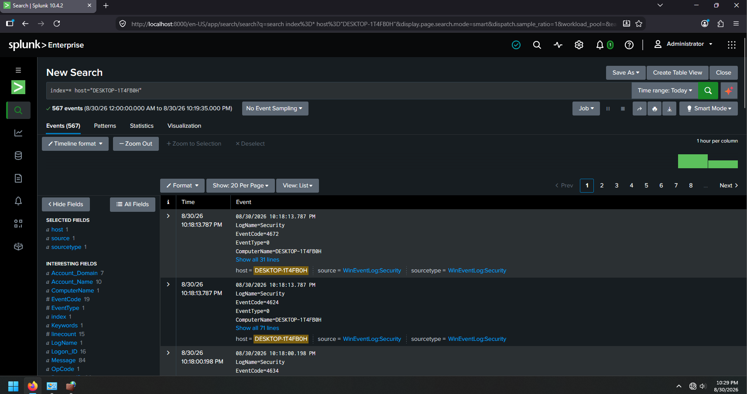
Phase 4: Attacking the Client being monitored to generate logs’
The attack command: hydra -l <username> -P <password-list> <target-ip> <service>
Breaking down the hydra command section by section and identifying what each command does.
-l this means “exact username” so this we will use when we know what the username of the client to be attacked is -L is used when we want the attack to use a list of possible usernames from the file. Rather than -l then followed by <username>. -L will be followed by the <file>
-P <password-list>
- this refers to our payload or our file with the list of passwords that hydra will use to attack the target client. This will be what our brute force will us. Alternatively, is we use the -p (the lowercase version) it will only use 1 password for guessing.
<target-ip> (self explanatory)
<service>
- Here we will put which protocol to attack, either rdp (remote desktop) or smb (server message block) btw, server message block is the protocol for sharing files with other devices within the same network.
Afterward lets create a password.txt file which will serve as our payload in here we will input the false password along with the correct password so can we generate logs within splunk and see the effects of brute force on a client being monitored by splunk.

Now conducting the attack using what we’ve learned.
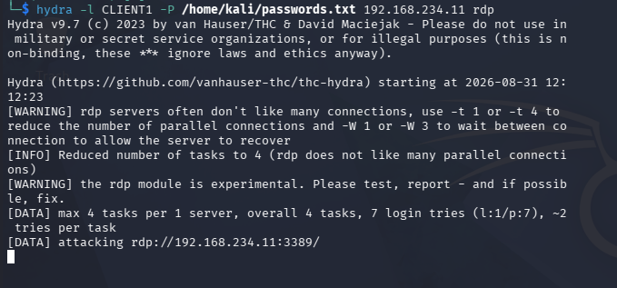

Results of the attack:
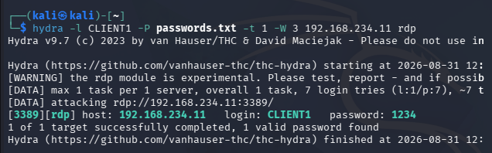

Splunk index Result:
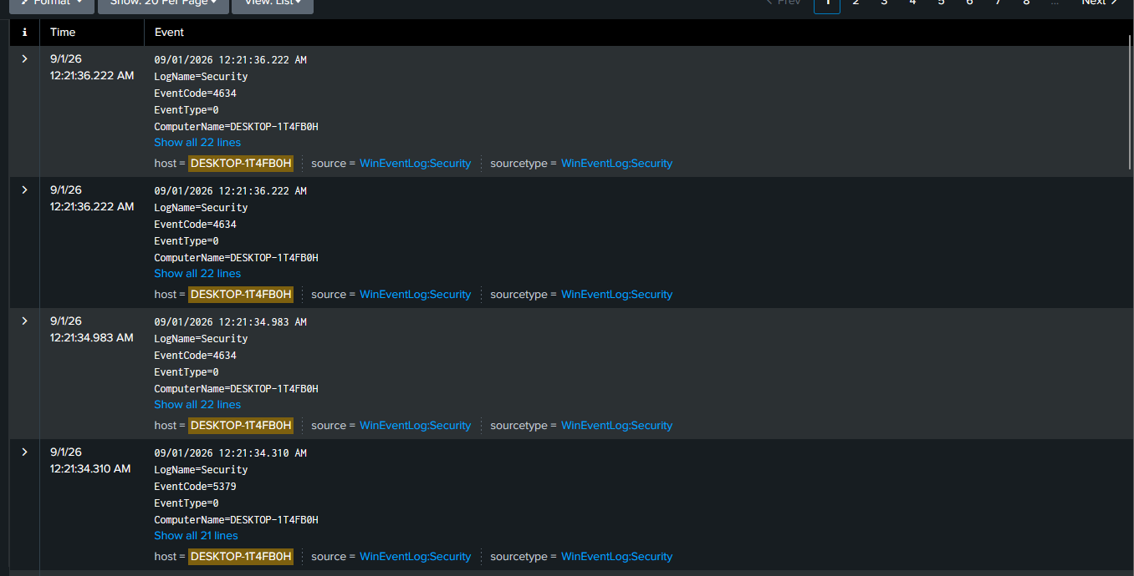
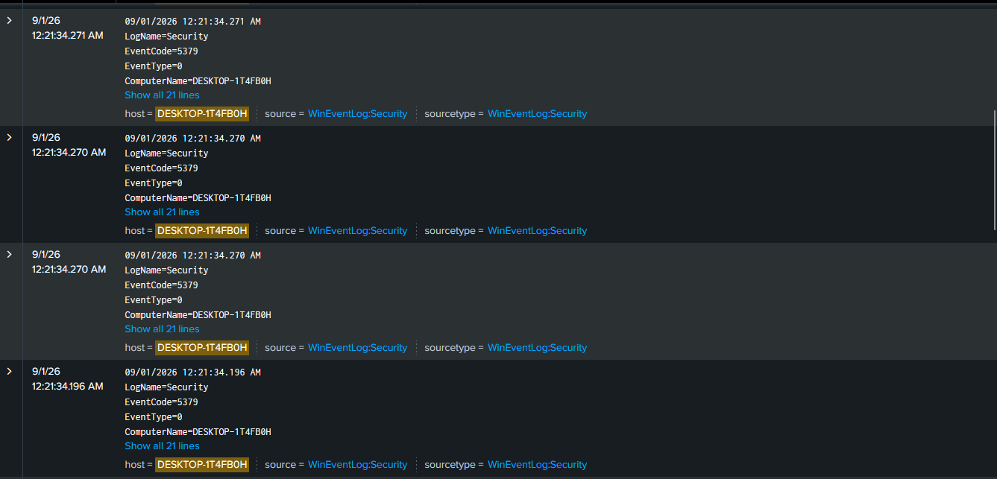

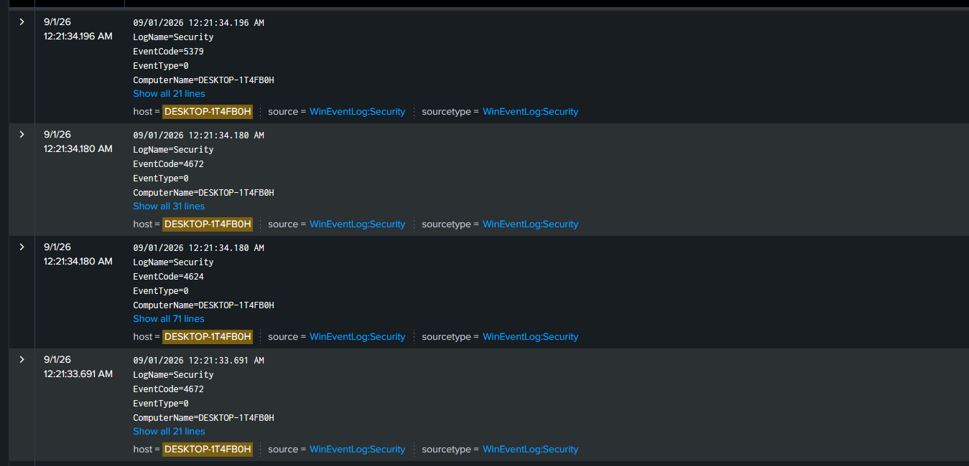

Error code notes:
4634 – account logoff
5379 - This event occurs when a user performs a read operation on stored credentials in Credential Manager.
4672 – special privileges assigned to new logon. This tells us that the account that just logged in has admin level privileges
4624 – successful account logon
4625 – unsuccessful account logon
Conclusion formed: If we were to read the different events in the correct order, we can see from the events that there were numerous failed attempts at trying to login onto client1 after a few attempts someone has successfully logged on into Client1 someone with privileged permissions as we can see from the 4624+4672 event codes. Then proceeded to do checking stored credentials, then logged off shortly afterwards.
By this we can conclude that this does not resemble a user login as the once the “user” logged off shortly afterwards which does not resemble a human doing work at his desk. This reflects the action of hydra wherein it tested multiple passwords and once it returned with a successful login, it dropped the session.

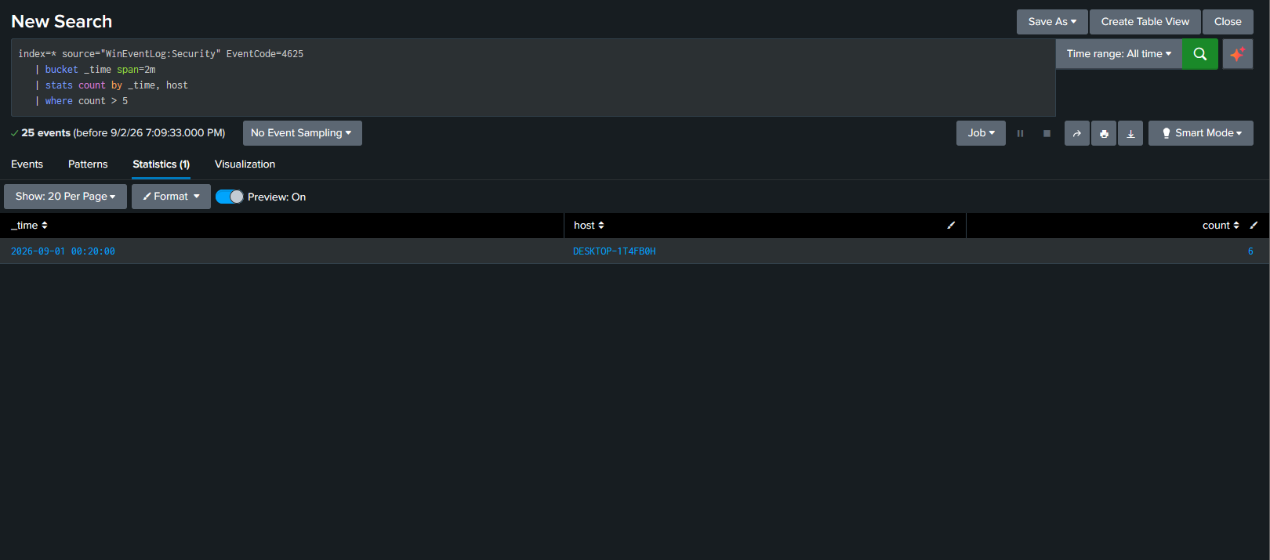
Above are the results from using the search query:
index=* source="WinEventLog:Security" EventCode=4625
| bucket _time span=2m
| stats count by _time, host
| where count > 5
Lets dissect the search query we used.
index=* source="WinEventLog:Security" EventCode=4625
- we choose our index, the source, the the corresponding eventcode that reflects failed logins.
| bucket _time span=2m
- What bucket does is group up all the events depending on the condition you set, in this case we used time span=2m along with bucket which means that all happened which happened around the span of 2 minutes are grouped together thus we can see we only got 1 result, if bucket were not used those events would be displayed separately

| stats count by _time, host
- Displays the events statistically by sorting them by their count and host.
| where count > 5
- Where the count which we used in the 2nd pipe is greater than 5.
Conclusion from this:
In a span of 2 minutes there have been more than 5 failed attempts at logging in to our specifically 6 attempts within the span of 2 minutes or less. This does not resemble a human failed login, 6 failed password attempts in the span of 2 minutes does not seem humanly possible unless if a user intentionally spammed wrong passwords.

Phase 5: Creating alerts rather than relying on manual searches.
Using the result we got on phase 4 by using the searcy query:
index=* source="WinEventLog:Security" EventCode=4625
| bucket _time span=2m
| stats count by _time, host
| where count > 5
Or by using a different query which doesn’t make use of the time
index=* source="WinEventLog:Security" EventCode=4625
| stats count by host
| where count > 5

Now on the top right of the search query lets save the search query as an alert
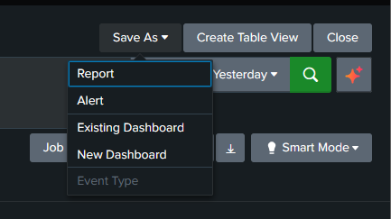

Add the following as the title and description
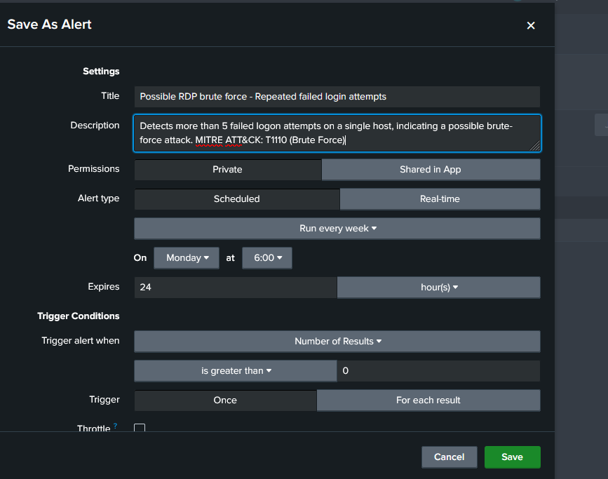

Note: MITRE ATT&CK: T110 is the id associated with brute force attacks this includes:
T110.1: Password Guessing
T110.2: Password Cracking
T110.3: Password Spraying
T110.4: Credential Snuffing

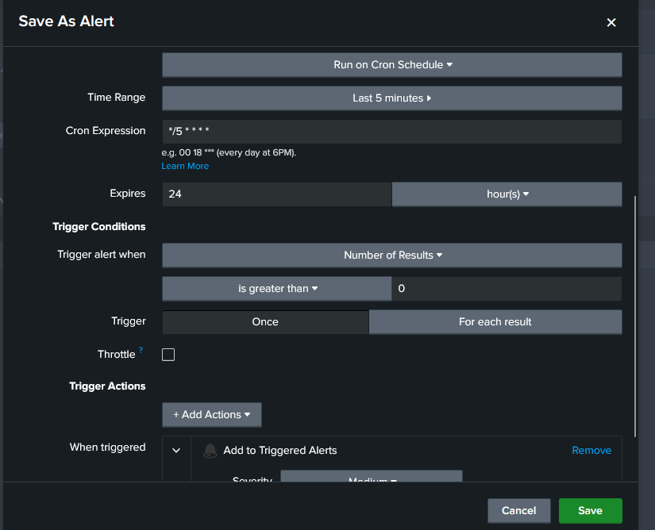
Take note of the time range we set, last 5 minutes. This means that it will run every 5 minutes and look at all the failed logons within that timeframe which exceeded 5 counts or attempts. The condition of the exceeded 5 count attempt came from our search query which we saved as an alert:
index=* source="WinEventLog:Security" EventCode=4625
| stats count by host
| where count > 5
For our trigger actions we used add to triggered alerts. This means that everytime the alert runs we can see it in the Trigger Alerts section.

Testing the alert we created
Now back to our linux vmware, we will proceed to once again simulate a brute force attack on the rdp of client 1 using hydra.
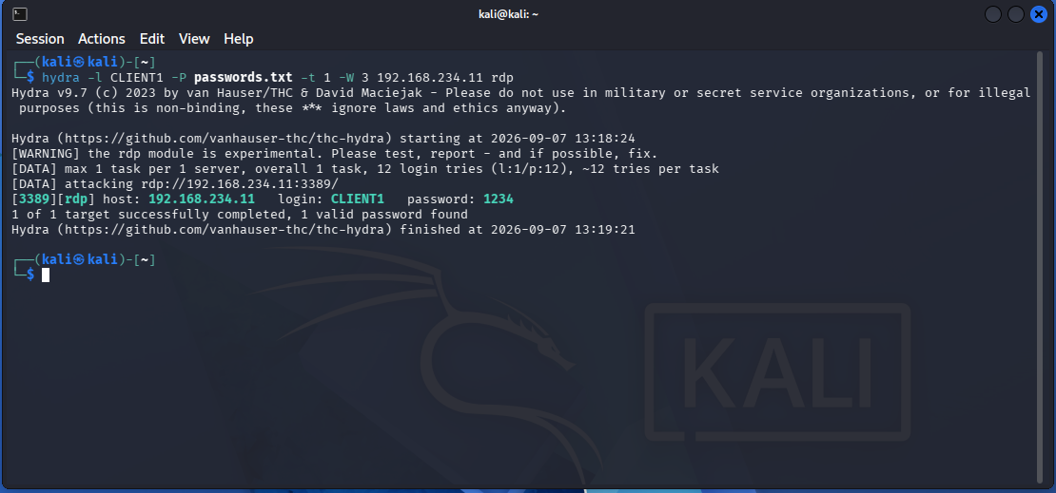
After attacking, lets now return to our splunk SIEM and check our alert caught the brute force attempt.
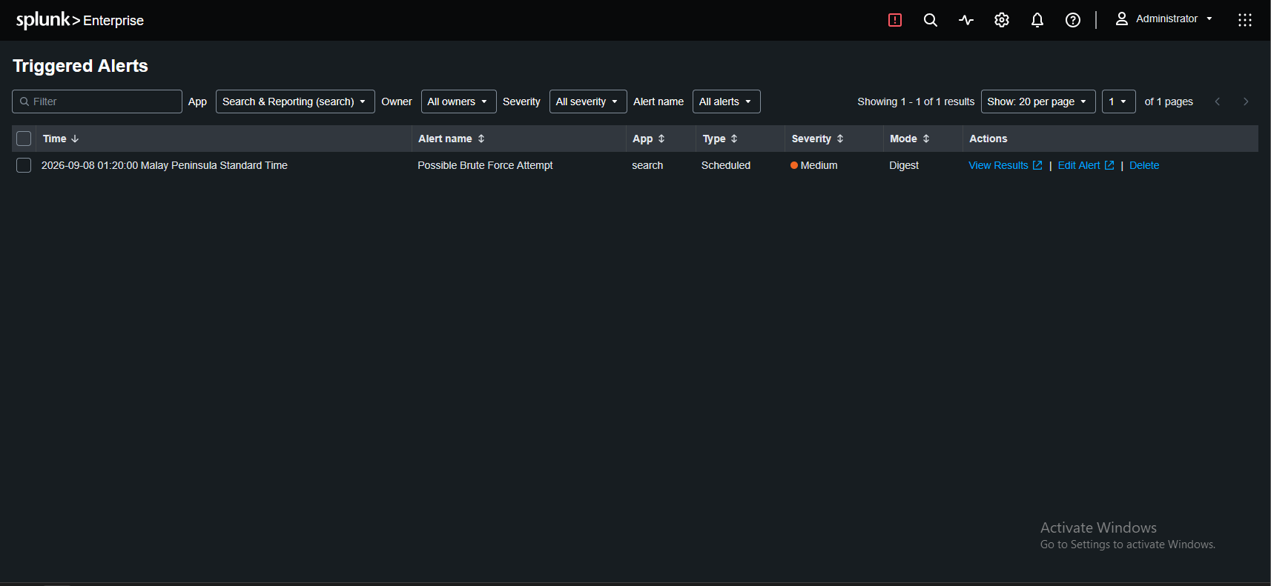
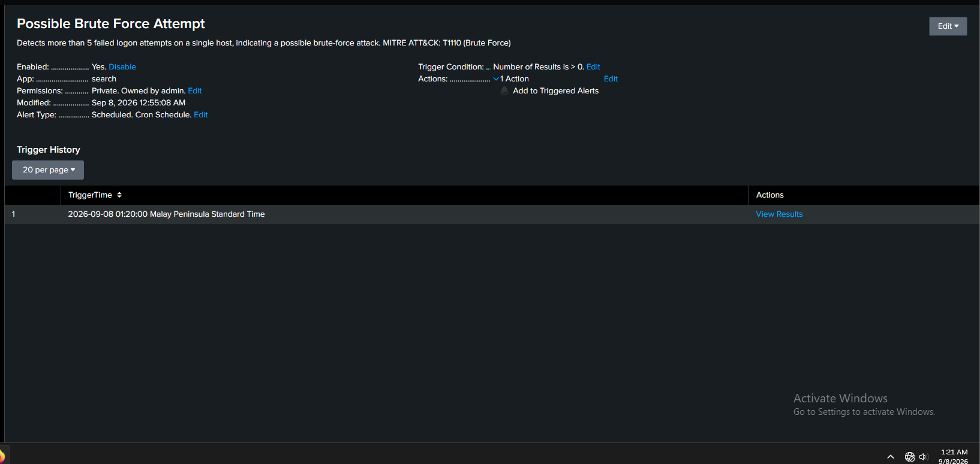
Upon checking the alerts tab we can see that the alert caught a possible brute force attempts. Lets check the View Results.
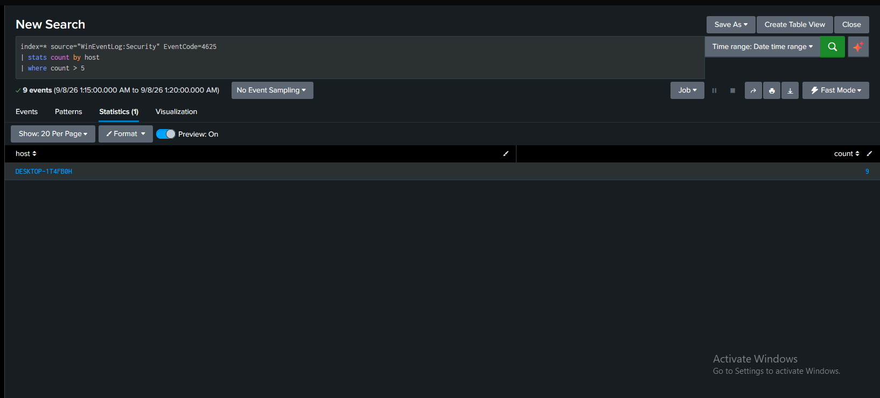
Upon further expanding the alert by pressing the view results here we can see what the alert found. Our client being monitored recorded 9 failed attempts in the span of 5 minutes.

Now that our alert works as intended, we will be making a way so we’ll get notified whenever our alert gets triggered so rather than going to the triggered alerts tab manually to see if any alerts have been triggered we’ll be able to see automatically anything that happens through the integration of webhooks. For this specific scenario I’ll be using discord to receive the triggered alerts from splunk.
Now to do this firstly get a webhook from your channel in discord. Once we have it lets proceed to splunk and navigate back to our alerts tab where we will edit our alert.
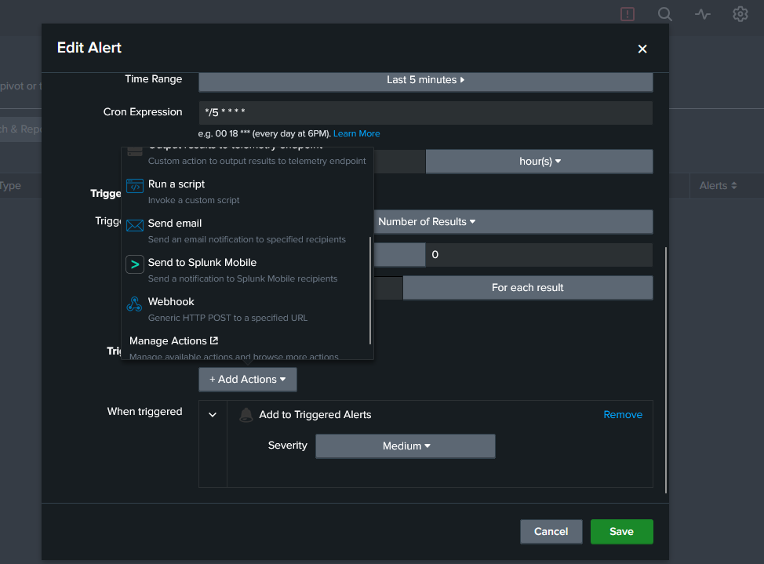
For here we’ll be using run a script, as webhooks for splunk and discord are not reliable as discord requires a content field. But nevertheless we will still be using a webhook but we’ll be using it on a script we’ll make which will send the alert to our discord channel.
The script we’ll be using
curl -H "Content-Type: application/json" -d "{\"content\": \"Possible RDP Brute Force detected on your monitored host\"}" "DISCORD _WEBHOOK_URL"
Dissecting the script:
Curl
– also known as client URL, its a command line tool that sends web requests. In our case, its sending data to discord through the use of our webhook

-H “Content-Type:application/json”
- this is our header, its telling that what we’re sending or the content that we are sending to discord is in json format. This is needed so discord knows how to read the message we are sending.
-d "{\"content\": \"Possible RDP Brute Force detected on your monitored host\"}" "DISCORD _WEBHOOK_URL"
- this is data that we are being sent or the content that we want to send in discord from our splunk siem. Here you can see we have the content field, whatever text we put in this section will be what discord displays.
- the reason it looks like this is because of JSON, this is the json format requires. Specifically it requires a “key” and a “value” pair. The keys and values are displayed as
“key”:”value” curly brackets at the front and the end of a key and value pair are also required so it becomes
{“key”:”value”}
So in our case you can see “content”:”Possible RDP Brute Force”}
But as you can see we have multiple \ or backslashes, there are commonly used to escape quotation marks because as you can see we have multiple quotation marks in our script, so to escape each quotation mark and execute the script we want and obtain the function we want we use these backslashes.

Now lets proceed to actually putting the script in our alert.
Firstly, we need to create a .bat script in our bin/scripts folder in splunk. Afterwards, lets the file name of our .bat script we just made in our alert section.
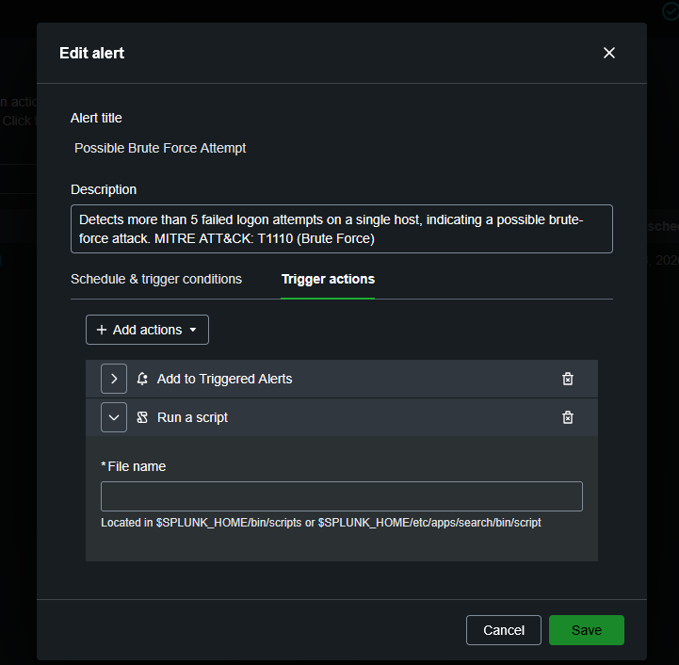
Once the setup is finished, you should receive a message on your discord and you now have a fully working alert notification system
